**Instructions**:

Complete the tasks below and bring your homework to the next class.

Task 1: What are the names of the following data models?

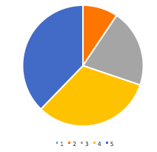 pie chart

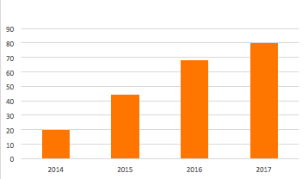 colunm diagram

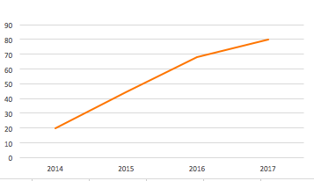 line chart

Task 2: Match the following phrases to describe the lines below:

*remain steady // fluctuate // slightly decrease // sharply decrease // sharply increase // go up a little*

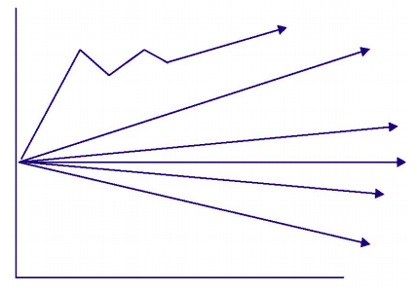

*Flactuate*

*Sharply increase*

*Go up a little*

*Remain steady*

*Slightly decrease*

*Sharply decrease*

Task 3: Plot the amount of hours you get on average each week on to the graph below.

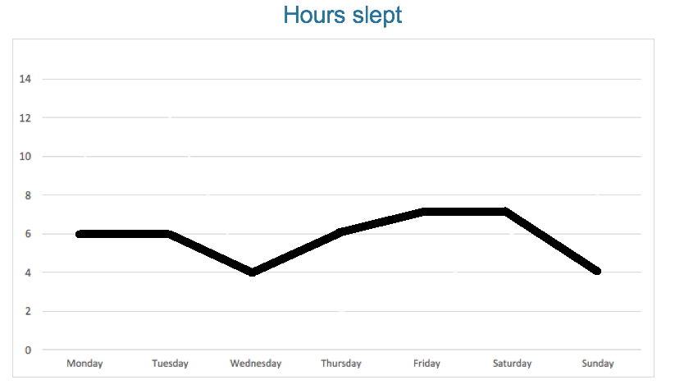

Task 4: Using the language in task 2 as a guide, describe your graph in 150 words.

My hours slept in the evening experience dramatically regular fracture during a week, which is a very sad story in fact. During Monday to Tuesday, my sleeping times remains steady at about 6 hours per night as there isn’t any big ddl being due during that period. However, when it comes to Wednesday, it drops to 4 hours because I have to handle the datas and prepare for tomorrow’s physical experiment, which is always difficult, complex and time-consuming and I always put it off until the day before experiment. Fortunately, after the whole Thursday’s suffering, I have chance to have a good rest for tomorrow’s general chemical quiz, so my hours slept comes back to 6. As for Friday and Saturday, I prefer sleeping more than stay up late playing games or watching vedios, so my hours slept increases slightly to 7. However, at Sunday’s night, I usually have to make ppt for tomorrow’s biological presetation and only get a little sleep. Therefore, my sleeping times decreases sharply to 4 hours……